Artificial Neural Network

for Spam Email Classification

Ian R. Stewart

November ${26}^{th}$, 2018

Fall 2018 – COSC 528
Project 4

Abstract
INSERT

Table of Contents
Abstract 2
1 Introduction 4
2 Data Exploration 6
3 Data Analysis 9
References 11

List of Tables
Table 1: Email dataset feature labels and data types. 6

List of Figures
Figure 1: Example three-layer neural network. 4
Figure 2: Order of dataset with respect to classification. 7

1 Introduction
In this project, an artificial neural network is created using a backpropagation algorithm to classify an email with specific features as either spam or non-spam (i.e. binary classification). Artificial neural networks are ideally suited for classification problems, where the analysis goal is to classify a data entry based on a particular set data attributes or features. Neural networks are used to transform the data into a relatively complex set of nonlinear basis functions or decision boundaries. A network is organized into layers with three general categories: input layer, output layer, and hidden layer. A user can choose to employ multiple hidden layers, in which the user can choose an optimal number of layers by iteratively tuning the configuration while training the network by using ancillary algorithms. Multiple hidden layers allow for representation of nonlinear relationships between the input and output layers to be accounted for (i.e. accounts for nonlinearly separable data).
The backpropagation algorithm is categorized to as a feedforward neural network, which means the information flows in a single direction from the input layer to the output layer, absent of any network loops or cycles. This approach is a supervised learning technique that essentially predicts the classification by modifying the input weights from the previous layer if using multilayer or from the initial input layer to produce an expected classification. The weights are calculated using a training dataset using fully-connected layers. To add context to this approach, a single hidden layer network is shown in the following Figure 1, where one input layer with a length equal to the number of data features and an output layer with the length equal to the number of classes (i.e. two classes in the span versus non-spam binary classification problem).
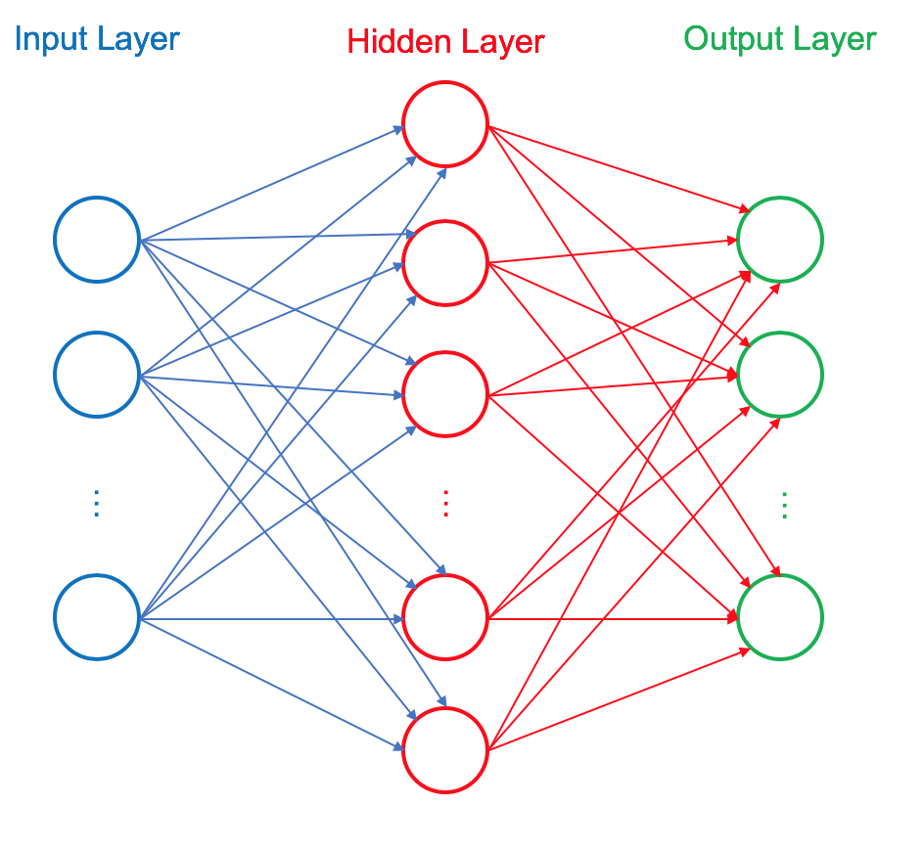
Figure 1: Example three-layer neural network.
Using the two-class (binary) classification for the spam or non-spam problem, the outputs layer can be hot-coded by vectorizing the output into a single column vector where $[0,1]$ or $[1,0]$ can represent spam and non-spam classification, respectively.
The backpropagation algorithm can be organized into five steps:
- Initialize neural network;
  - Description: Create network architecture using predetermined number of hidden layers and number of neurons per layer and initialize weights.
- Forward propagate weight;
  - Description: Propagate input signal through the hidden layers through until the output layer is reached. From Figure 1, this step essentially propagates the input features through the connection from left (input) to right (output).
- Back propagate error;
  - Description: Determine difference, or error, between expected output and calculated forward propagate output. From Figure 1, this step propagates the error from right (output) to the left (input).
- Train network on training data; and,
  - Description: Iterate randomly through the dataset to train the network by updating the weights via the weights from each iteration.
- Predict classification based on calculated layer weights.
  - Description: Use the calculated weights for the neural network to predict the classification of the test data.
The development and implementation of this algorithm in Python follows these steps to predict the classification for a set of test emails. Discussion regarding the creation and implementation of the Python functions are provided in the latter portion of the report (see Data Analysis section).

2 Data Exploration
The dataset utilized in this project contains 4,601 entries and 57 total columns or features with an additional feature containing the actual classification value. The data was found to be full with no null and absent of negative values in each feature, which is expected. Table 1 provides the data feature labels and the corresponding data types.
Table 1: Email dataset feature labels and data types.
Feature Label | Data Type |  | Feature Label | Data Type
word_freq_make | float64 |  | word_freq_labs | float64
word_freq_address | float64 |  | word_freq_telnet | float64
word_freq_all | float64 |  | word_freq_857 | float64
word_freq_3d | float64 |  | word_freq_data | float64
word_freq_our | float64 |  | word_freq_415 | float64
word_freq_over | float64 |  | word_freq_85 | float64
word_freq_remove | float64 |  | word_freq_technology | float64
word_freq_internet | float64 |  | word_freq_1999 | float64
word_freq_order | float64 |  | word_freq_parts | float64
word_freq_mail | float64 |  | word_freq_pm | float64
word_freq_receive | float64 |  | word_freq_direct | float64
word_freq_will | float64 |  | word_freq_cs | float64
word_freq_people | float64 |  | word_freq_meeting | float64
word_freq_report | float64 |  | word_freq_original | float64
word_freq_addresses | float64 |  | word_freq_project | float64
word_freq_free | float64 |  | word_freq_re | float64
word_freq_business | float64 |  | word_freq_edu | float64
word_freq_email | float64 |  | word_freq_table | float64
word_freq_you | float64 |  | word_freq_conference | float64
word_freq_credit | float64 |  | char_freq_; | float64
word_freq_your | float64 |  | char_freq_( | float64
word_freq_font | float64 |  | char_freq_[ | float64
word_freq_000 | float64 |  | char_freq_! | float64
word_freq_money | float64 |  | char_freq_$ | float64
word_freq_hp | float64 |  | char_freq_# | float64
word_freq_hpl | float64 |  | capital_run_length_average | float64
word_freq_george | float64 |  | capital_run_length_longest | int64
word_freq_650 | float64 |  | capital_run_length_total | int64
word_freq_lab | float64 |  | spam class | int64

The minimum value for all data is equal to 0.0, except for the three capital_run_length* features, which have a minimum value of 1.0. The maximum values are unique for each feature, which is expected as certain features are traditionally more common than others, such as the features word_freq_you versus word_freq_1999. The data features are further delineated by the following unique attributes in order in the dataset.
- First 48 features are continuous real values ranging $\left[0,100\right]$ that represent the percentage of words in the email that match the specific word (i.e. word_freq_WORD).
- Next 6 features are continuous real values ranging $\left[0,100\right]$ that represent the percentage of characters in the email that match the specific character (i.e. word_freq_CHARACTER)
- The next feature, capital_run_length_average, is continuous real value ranging $\left[1,…\right]$ that represents the average length of uninterrupted sequences of capital letters.
- The next feature, capital_run_length_longest, is continuous real value ranging $\left[1,…\right]$ that represents the longest of uninterrupted sequence of capital letters in the email.
- The next feature, capital_run_length_total, is continuous real value ranging $\left[1,…\right]$ that represents the sum of length of uninterrupted sequences of capital letters in the email.
- The final feature, spam class, denotes whether the email was considered spam $\left(1\right)$ or non-spam $\left(0\right)$.
Another observation is that the classifications are actually grouped together, where the spam classifications are the first 1,813 entries and the latter portion of the data (i.e. 2,788 entries) are all non-spam classification. This is an interesting finding, as a small training-test split for a cross-validation study can potentially cause classification errors if a sufficient amount of each group is not represented in the training set. Being a two-class dataset, the first portion of the data $\left(\sim 40\%\right)$ represent only spam email classifications and the latter portion (%60) of the data represents only non-spam email classifications, as illustrated in the following Figure 2.
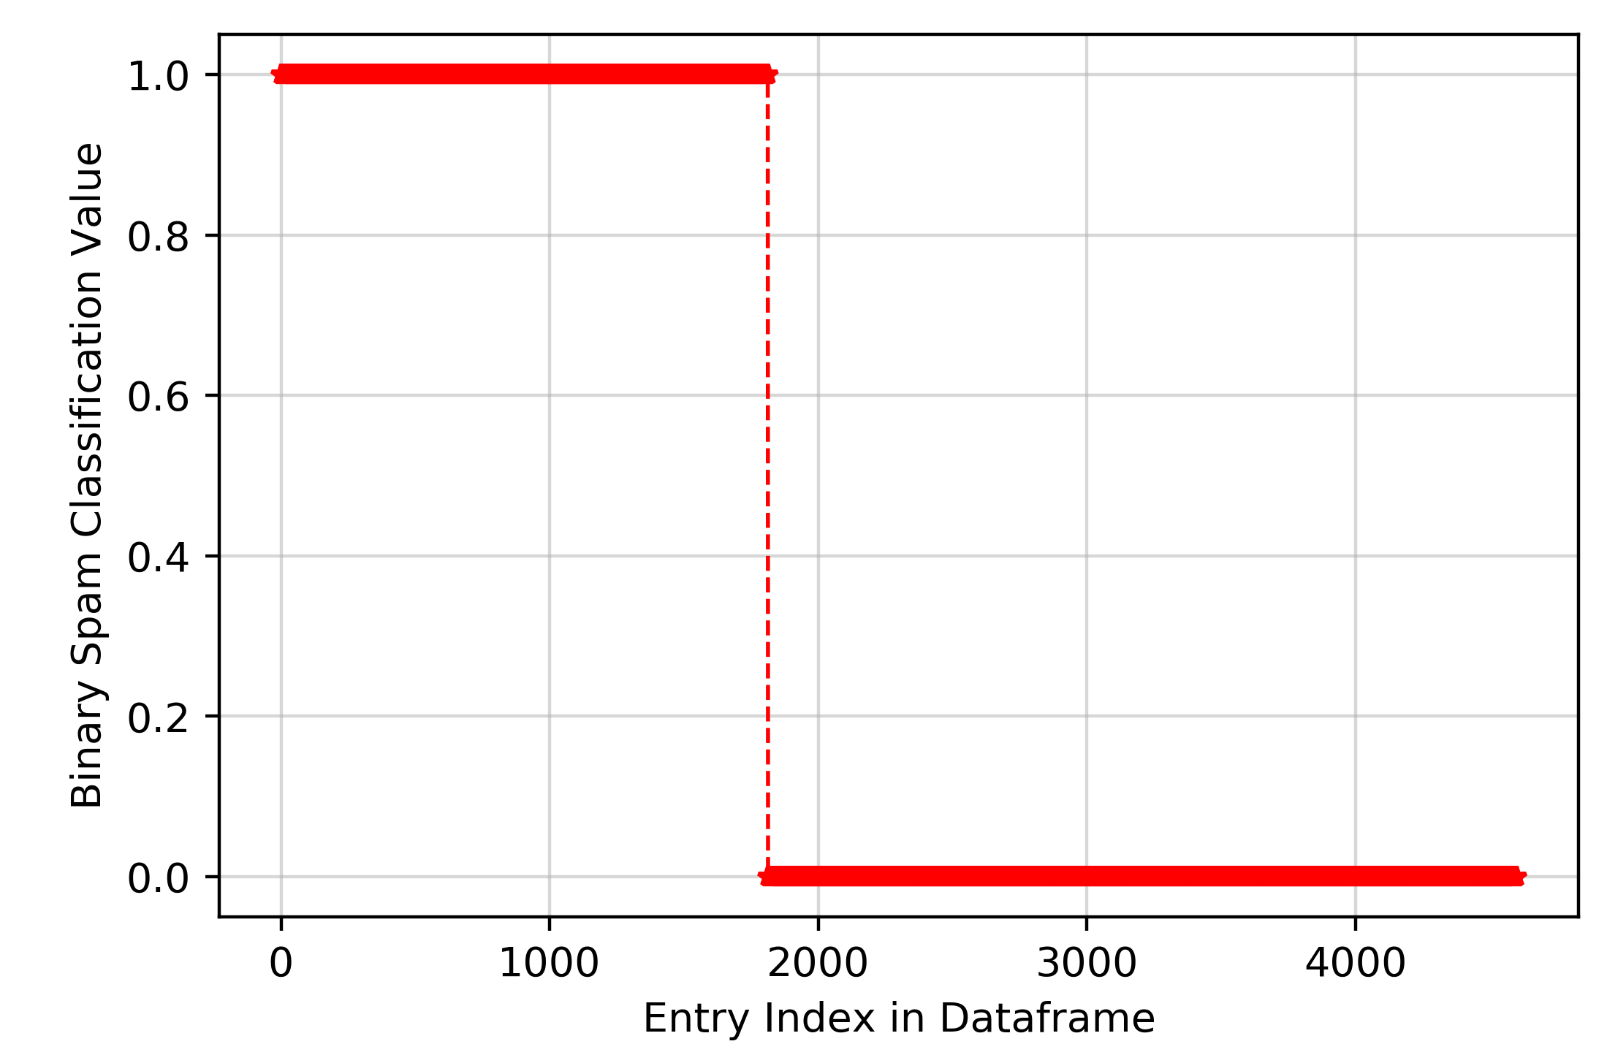
Figure 2: Order of dataset with respect to classification.

3 Data Analysis
When creating a neural network, several questions must be answered to building and optimizing the network, namely:

- How many hidden layers to employ to obtain an optimal predictive power?
- How many neurons per hidden layer is optimal?
- How to obtain answers to the previous two question?
Only one input layer is used for a network with the number of inputs based on the length of the known data features or metrics. Similarly, in this case the output layer is also known beforehand and represents the number of classes (i.e. two).

The network is first initialized by the created initialize( ) Python function within the ANN class, which accepts the number of inputs in the input layer, the number of neurons in the hidden layers, and the number of hidden layers. As each hidden layer has a set number of neurons, the weights must be maintained for the input and the bias. To store this information, the created initialize( ) Python function stores the data in a dictionary that holds the network weights for each layer in order (i.e. begins with the weights between the input layer and the first hidden layer and ends with the weights between the final hidden layers and the output layer). During the initialization step, the weights are randomly selected from a uniform distribution ranging form 0 to 1 using the Python library random via the function random.uniform( ) and the number of weight inputs for the hidden layers is one greater than the specific value of neurons to account for the bias at each layer. Before moving on the following steps described in the Introduction section, let’s examine the output for an initialized network with two inputs in the input layer, two hidden layers with three neurons per layer, and two outputs in the output layer. The initialize( ) function provides the following output from an array of length equal to the number of weights between each step (i.e. three in this example).

- Weights between input and first hidden layer:
[
{'weights': [0.7270700037509241, 0.7383627445080684, 0.18978193074880423]},
{'weights': [0.7869285898008361, 0.11191242288793657, 0.6323166547815777]},
{'weights': [0.5542929997136264, 0.6299108552149877, 0.036872224253109986]}
]

- Weights between hidden layers:
[
{'weights': [0.9541070703271004, 0.9002708967220981, 0.5574211004774138, 0.56239456051497]},
{'weights': [0.5772579431172555, 0.5744375394342741, 0.276212229019259, 0.5615663370673547]},
{'weights': [0.49917371980390934, 0.2289715704548373, 0.9165265896818503, 0.4831653543316994]}
]

- Weights between last (second) hidden layer and output layer:
[
{'weights': [0.7936276360327776, 0.9247539681130554, 0.08899479960010304, 0.6728626611317721]},
{'weights': [0.19170994036771682, 0.8864472297353635, 0.1201225021016884, 0.15257603530797048]}
]

From the created arrays, the hidden layers weights contain three neurons, indicated by the number of Python dictionaries in the array, and three weights for each neuron plus one weight the bias resulting in a total of four weights. The output layer array contains two Python dictionaries with a total of four weights, three of which correspond to the number of neurons and an additional weight for the bias. The length of the output array (i.e. two) is equal to the number of output neurons on the output layer.
Upon initialization of the weights, the forward-propagation step is performed. In this step, the user can specify the type of activation function to implement in the network; choosing one from the following list: logistic sigmoid, linear, or softmax function. The activation functions are shown in the following equations.
(Eq.1) $Logistic Sigmoid: f\left(x\right)=\frac{1}{1+e^{-x}}$
(Eq.2) $Linear: f\left(x\right)=x$
(Eq.3) $Softmax: f_{i}\left(x\right)=\frac{e^{x_{i}}}{\sum_{j=1}^{J}{e^{x_{j}}}} for i=1,…,J$
The softmax is dissimilar to the other two functions, in that it is not a function of a single fold from the previous layer(s). Essentially, the activation function maps the neuron input into a desired, predetermined range. The ranges for the functions offered in the create ANN( ) Python class are $\left(0,1\right)$, $\left(-∞,∞\right)$, and $\left(0,1\right)$, respectively. These function with calculate the unique output for the activated neuron and is used for forward propagating the output through a network. That this case, the created ANN( ) Python class will iterate over each neuron in a hidden layer, calculate the output based on the inputs from the previous layer and the activation function chosen, and forward propagate the weights through each layer until the output layer is reached. Let’s test the activation functions on the previous example network and examine the output.
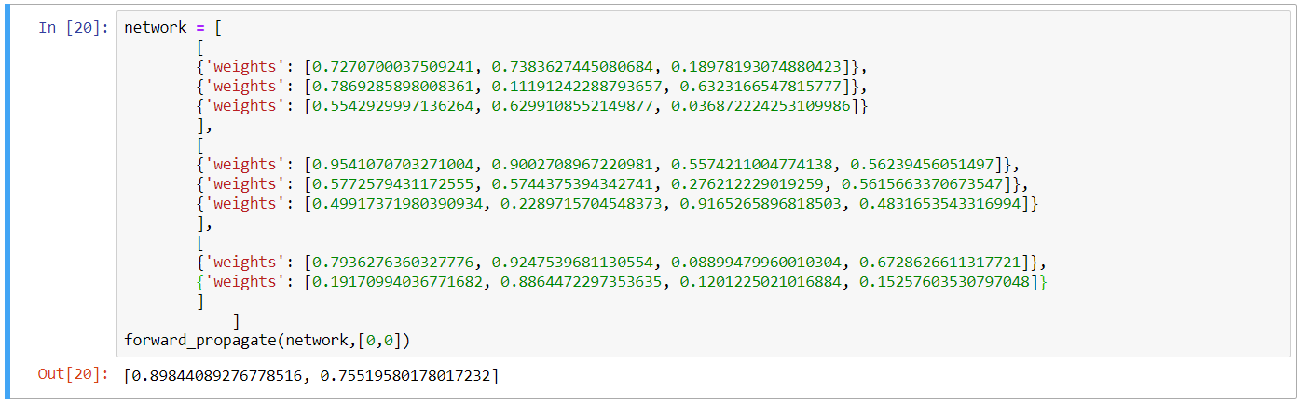
Figure 3: Forward Propagation output for example network using a sigmoid activation function.
The default activation function for the created forward_propagate Python function is sigmoid, which is shown in the previous Figure 3. The function propagates the input values $\left[0,0\right]$ through the network and produces an output array with two values corresponding to the neurons in the output layer. This array will be compared to the known classification values using an error calculation.
To select the appropriate weights at each layer, the error between the forward propagated values and the known values in a training set can be used. This is accomplished by using the first derivative of the activation function to calculate the output slope from a neuron and multiplying the error (i.e. difference between the calculated and known values) by the derivative, or slope. This calculation formula is provided below.
(Eq.4) $Error=\left(Calculated Value-Known Value\right)*Derivative\left(Known Value\right)$
The known values correspond to the classification value in the training set. This calculation is relatively straightforward for calculating the error for the output layer neurons but is more convoluted for the hidden layers. The hidden layer error calculation begins with the initial error output layer calculation and iterate through the network layer-by-layer until the input layer is reached, updating the weights along the way. That is, the error is calculated backwards from the output to the input layer across the hidden layers, hence the term back propagation. The error for each neuron in the hidden layers is calculated using the same method provided in Eq. 1 via the product of the error and slope (i.e. derivative of the chosen activation function). The following pseudocode (Python) illustrates the general method of implementation, where the errors are calculated by iterating through the forward propagated network in reverse order.
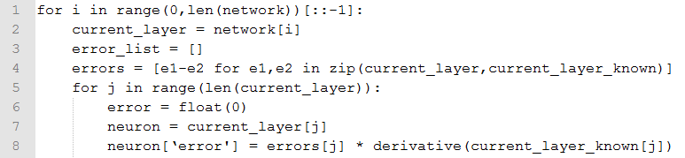
Figure 4: Pseudocode for back propagation.
The Python class uses a dictionary to hold the calculated errors between the expected and known values. The dictionary can then be called layer-by-layer to back propagate the error for each neuron in each hidden layer. The loop in the pseudocode will continue for each hidden layer until the input layer is reached.
Now that the error has been calculated for the initial network weights, the weights need to be updated accordingly to converge on the correct, known classification. This is accomplished in an online manner, where the weights are updated each iteration. Ideally, the weights would converge to a value, thus the error would converge to a minimum given many iterations, or epochs.

References
Alpaydin, Ethem. Introduction to Machine Learning. Third Edition. The MIT Press. Cambridge, Massachusetts. (2014). ISBN: 978-0-262-02818-9.

Another common problem set for neural networks to solve is regression, where a neuron activation is obtained by the weight sum of the inputs for each layers, similar to linear regression.

